**Computer Fundamentals - Assignment 2**

**Assignment Title:** Exploring Windows OS, Command-Line Tools, Printers, Registry, and File Systems  
**Due Date:** 20th December 2024  
**Weighting:** 30%

**Assignment Objective**

This assignment is designed to evaluate your understanding of the fundamental components of operating systems, command-line tools, registry management, printer configuration, and file systems. You will apply theoretical knowledge, practical skills, and creativity to solve problems and demonstrate your learning outcomes.

**Assignment Instructions**

You are required to complete the following tasks. Be creative in your explanations and make use of various formats such as **written explanations, screenshots, diagrams, or video recordings** to effectively present your work.

**Task 1: Windows OS**

1. Compare the essential differences between Windows 7, 10, and 11 in the form of a table. Use diagrams/screenshots to support your analysis. [6 Marks]

Answer:

|  |  |  |  |
| --- | --- | --- | --- |
| **Feature** | **Windows 7** | **Windows 10** | **Windows 11** |
| Started | 22/10/2009 | 29/06/2015 | 05/10/2021 |
| Interface | Classic, Start menu with Taskbar | Start Menu with live Tiles, different design | Start Menu in the center and rounded corners |
| Performance | Optimized for older hardware | Improved performance DX12 support | Optimized for modern CPUs, gaming and multitask |
| Gaming features | Basic support | Xbox integration, Game mode, Directx 12 | Enhanced gaming focus |
| Security features | Basic | windows Defender and secure boot | Secure boo, advanced phishing protection |
| Microsoft store | Not available | Limited apps | Supports Android apps |
| Updates | Manual | Continuous with windows for service | Streamlined updates, reduced size and frequency |
| System | 1GHz CPU, 1GB RAM, 16GB storage | 1GHz CPU, 1GB RAM, 16GB storage | 1GHz CPU, 4GB RAM, 64GB storage, TPM 2.0 |

Windows 7 Interface:

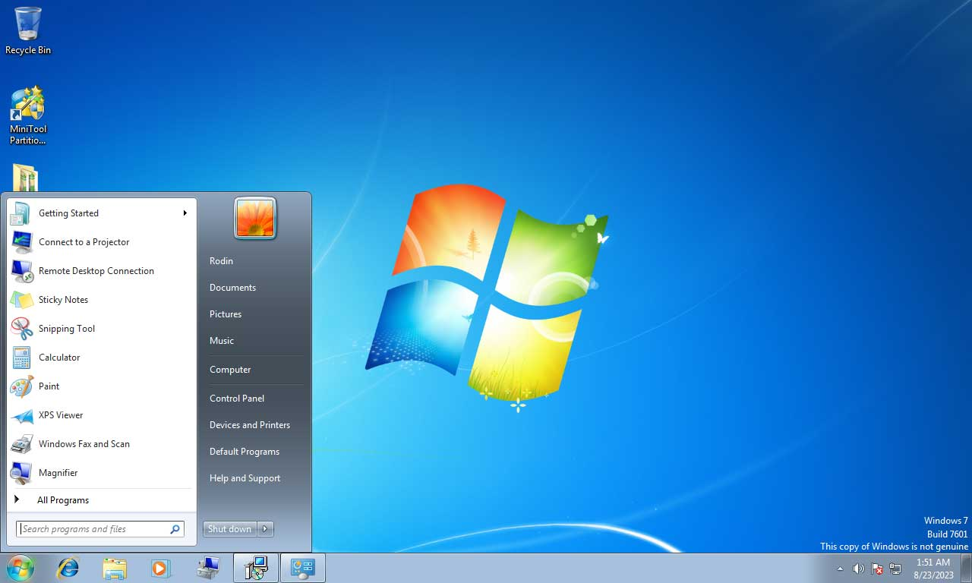

Figure - Windows 7 Interface - https://www.minitool.com/backup-tips/windows-7-vs-windows-11.html

System:

Figure - windows 7 system - https://www.minitool.com/backup-tips/windows-7-vs-windows-11.html

Windows 10 Interface:

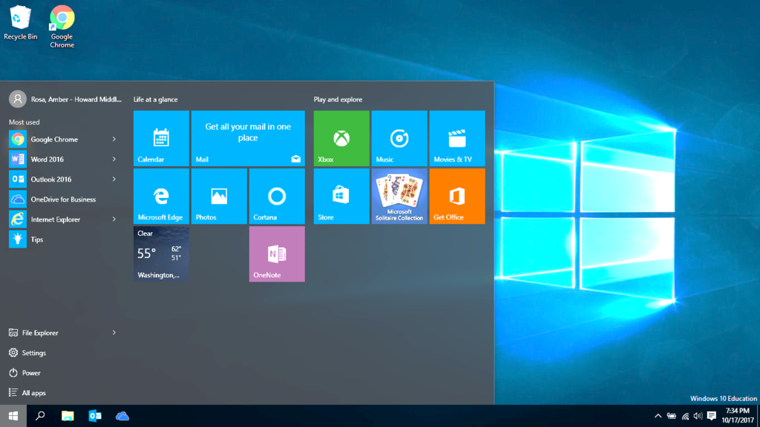

Figure - windows 10 Interface - https://quizlet.com/487726053/windows-10-interface-diagram/

System:

Figure - Windows 10 System - https://quizlet.com/487726053/windows-10-interface-diagram/

Windows11 Interface:

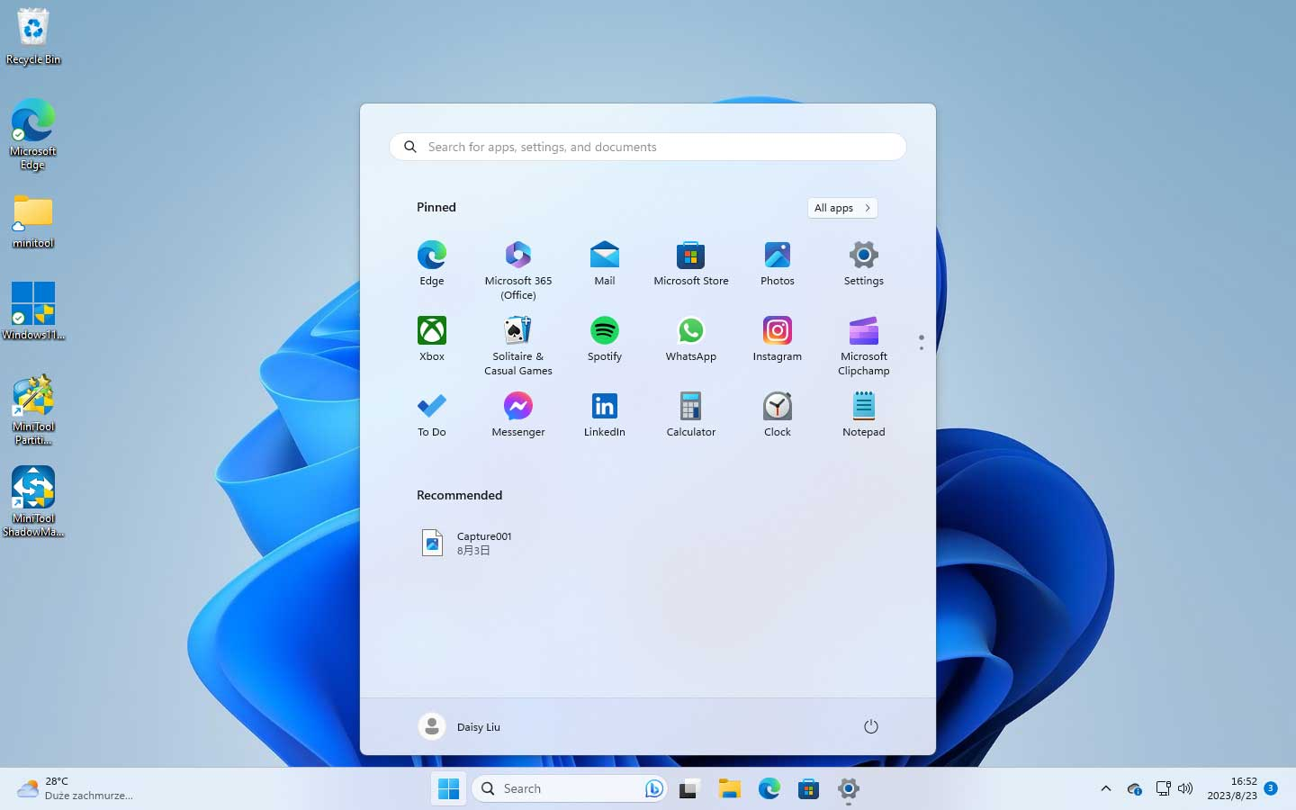

Figure - Windows 11 - https://www.minitool.com/backup-tips/windows-7-vs-windows-11.html

System:

Figure - windows 11 system

1. Explain the various levels of authority in Windows (Administrator, Standard User, Guest, etc.) and demonstrate how these can be set up. [4 Marks]

**Creative Hint:** Use visual aids such as flowcharts or recorded tutorials to highlight the configuration steps.

The difference levels of authority in windows between Administrator and guest are:

**Administrator account:**

Control: Administrators have complete control to the system, where they can install or uninstall software, change system settings and manage other accounts.

System configuration: they can configure the system and polices, that can interfere with all users on the system.

Security management: Administrators can set permissions for other users, manage security settings and access their files and data on the system.

User management: They have complete access to users account, they can create, read, update, delete (CRUD) and assign roles or permissions.

**Guest account:**

Limited access: Guest accounts have restricted permissions. Only basic access to functionalities and specific access to files/folders.

Configurations: Guests cannot change anything in the settings system (cannot install software)

Temporary Use: Allow visitors to use the system and not cause any problem with security.

**Task 2: CMD Tool**

1. Open the CMD tool and perform the following: [6 Marks]
   * Navigate to the C: drive.
   * Create a directory named *MyDirectory*.
   * Write and demonstrate a command to delete all Word documents (*\*.docx*) in this folder (even if it’s empty).

Answer:

To create a directory in the CMD Tool we going to write the following steps:

Step 1 – With CMD Opened, it will stay in a folder called CD:\USERS\LUCAS – what means the location where the information put it in there is going to be after saving.  
To go back to the CD: DRIVE we must type in the CMD tool:

Cd .. – typing this code means that we want to go back to the folder before, we must do it twice to go back to the cd drive. Follow the picture below:

Step 2:

It is necessary to type the following things:

Mkdir to create a folder and type the name of the folder, in this case is going to be MyDirectory, after creating the folder you create the file, I am using the VI, but because we are using windows, we must type VIM. Follow the picture as a demonstration.

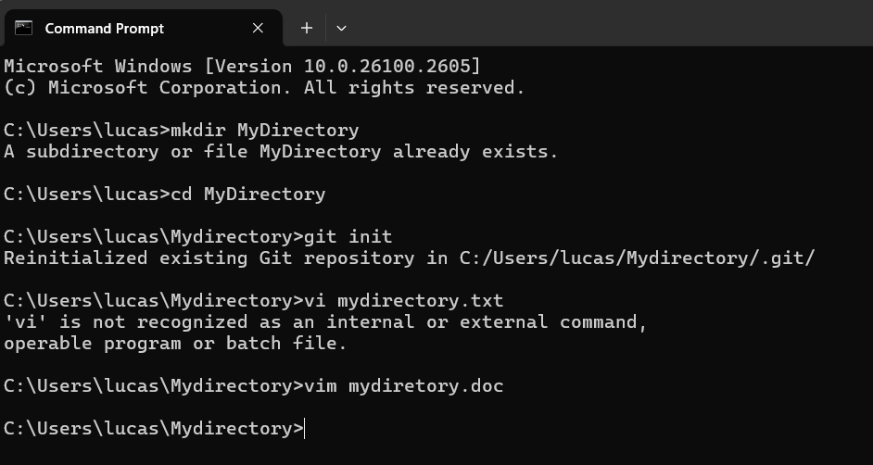

Step 3:

When you create the file using VI, automatically you are moved to inside the file.

To type in the file, you must press the button “I” that means Insert.

Once the insert is there, you can write whatever you want to.

1. Explain the purpose of the pipe (|) command in MS-DOS, providing a practical example.

[2 Marks]

**Creative Hint:** Record your screen while performing CMD commands or use annotated screenshots to explain each step.

**Task 3: Printers**

1. Demonstrate how to add a printer and set it as the default printer in Windows. Provide step-by-step guidance with screenshots or video demonstrations. [2 Marks]

**Task 4: Registry**

1. Explain the purpose of the Windows registry and its role in system configuration. [2 Marks]
2. Identify and demonstrate the tool used to modify the registry (e.g., *regedit*). [2 Marks]

**Creative Hint:** Provide examples of real-world scenarios where registry modifications are helpful, and back them up with recorded tutorials or visuals.

**Task 5: File Systems**

1. Compare and contrast FAT and NTFS file systems in terms of performance, security, and compatibility. Use a table or infographic for clarity. [3 Marks]
2. Explain how to configure a hard drive to enable dual operating systems (e.g., Windows and Linux). Demonstrate the process of partitioning a drive and configuring bootloaders.

[2 Marks]

1. Explain the purpose of drive defragmentation and how to perform it in Windows. [1 Mark]

**Creative Hint:** Use diagrams or infographics to explain the differences between FAT and NTFS and create a visual guide for dual-boot setup.

**Deliverables**

1. A typed document (PDF) containing:
   * Written explanations, tables, and diagrams.
   * Annotated screenshots.
2. Optional: Video recordings demonstrating specific tasks (e.g., CMD commands or registry configuration).
   * Submit video links in the document or upload them to a platform such as Google Drive or Upload it on YouTube as private (ensure access permissions are set correctly).

**Assessment Criteria**

* **Completeness:** All tasks are addressed thoroughly.
* **Clarity:** Explanations are clear and supported by screenshots, diagrams, or recordings.
* **Creativity:** Effective use of visuals and videos to enhance understanding.
* **Accuracy:** Commands, steps, and configurations are correct and replicable.
* **Presentation:** Well-structured document with proper formatting and references where applicable.

**Submission Details**

* **Deadline:** 20th December 2024
* **Format:** PDF document with embedded screenshots/diagrams, and links to videos if applicable.

**Note:** This assignment encourages creativity. Think critically and engagingly present your solutions using a mix of text, visuals, and recordings. Ensure all instructions are followed and submit your work by the deadline.

Good luck! 😊

REFERENCE:

TASK1:

Question 1:

<https://quizlet.com/487726053/windows-10-interface-diagram/>

<https://www.minitool.com/backup-tips/windows-7-vs-windows-11.html>

Question 2:

<https://www.quora.com/What-is-the-difference-between-an-administrator-and-a-guest-account>

TASK 2: